Annex 6: Previous Training Activities
Sample Training Agenda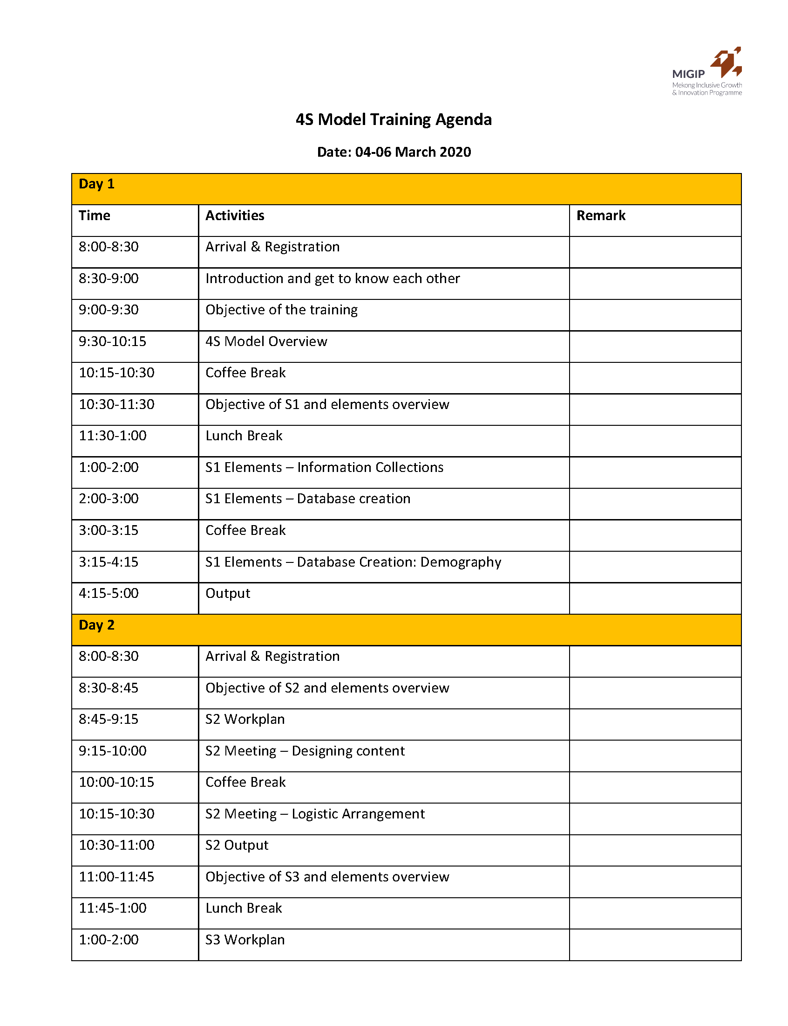
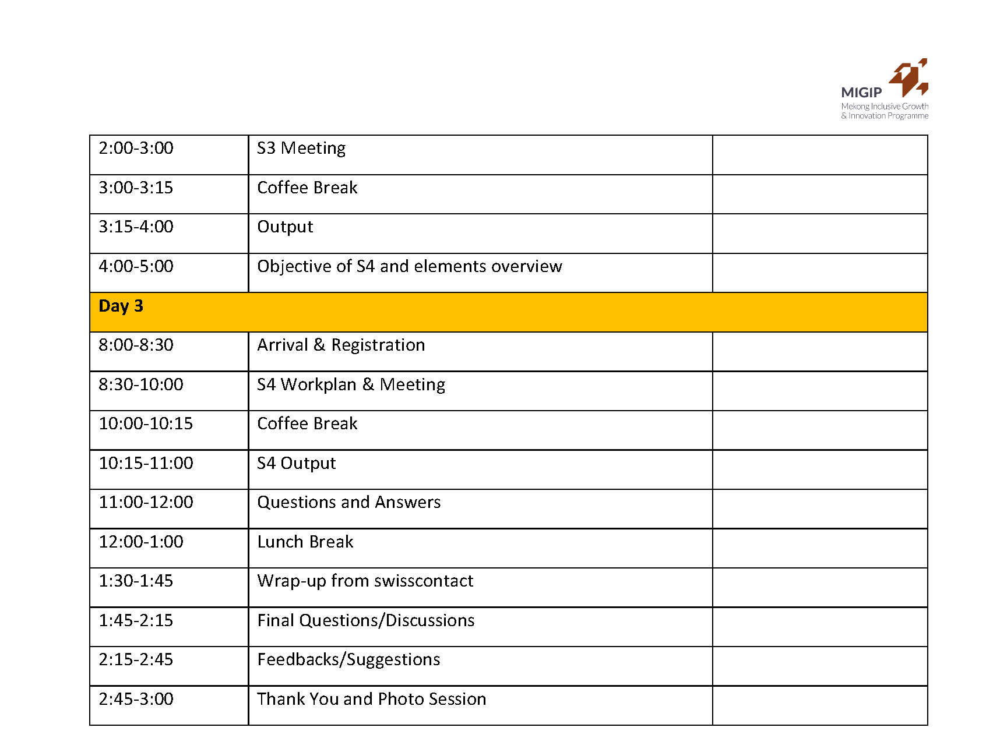
Sample Training Activities
Activity 1: Introduction and Get to know each other
Previous activity: Introduce your name and position with their favorite fruit.
Why: Plain introduction with just name and position highly tend to leave no impression for other people to remember the person, therefore let the participant give a different detail along with their name is the best way to keep people remember each other. For example, the melon guy.
How:
- Start with the facilitator team to give the example (My name Sovannaret and I like Mango) then ask participants to do the same.
- At the last person, the main facilitator should recap by pointing out random participant to remember the other participants.
- Select as many as people per time allowed.
Tips: Google “Get-to-Know-you” games for more interesting activities. However, always remember that your games have to be tailored according to your audiences. If people with higher position join the training, make sure it is not too childish to do.

Activity 2: Creating Questionnaires and Database
Previous activity: Brainstorm questionnaires with participants to get the most relevant information for their target customers.
Why: Because the sale team knows the best questions to get to their customer, they should be the one who provide inputs in creating questionnaires for the customer database. They also know best which questions that are sensitive for the customers and which are the most required to target the right customers.
How:
- Divide the participants in small group or pair to brainstorm up to 10 information/questions that they think are the most relevant and helpful in targeting their customers. Leave the basic information (name, contact, address etc.) out of the brainstorm.
- Set the time under 10 mins for the Brainstorming. The facilitators can help by questioning here and there if participants seem to be stuck.
- Once the session is up, bring up the Bloo form on the slide for everyone to see and create the form based on the selected questionnaire.
- One by one, the group or pair should voice out their brainstormed questions and the whole participants can agree or disagree to select the questionnaire to be put in the form.
- The facilitator should assist the group in choosing the most convenience format for each questionnaire by explaining clear and conducting demonstrate of the formats (single select, multiple select, checkbox, star rating etc.)
Tips:
- Do not set the time for brainstorm session too long or the participants will come up with overwhelming questionnaires. The team should focus on priority questions because at the field they will not want to spend too much time on one person.
- Allow more time for the discussion, and facilitator always make sure that the questions are comfortable for both the sale team and the customer or else the questions are likely not be asked or answered correctly and so lead to missing/misleading information in the database.

