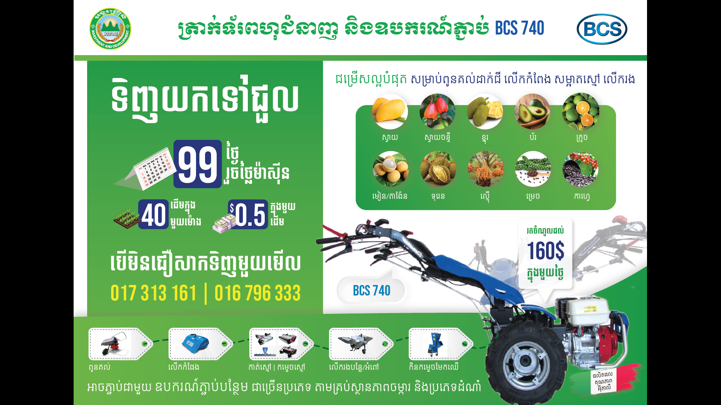**Annex 4: Example of Existing Branding Materials**

