Annex 11: Market Map Sample
Sample of Market Map and Actors
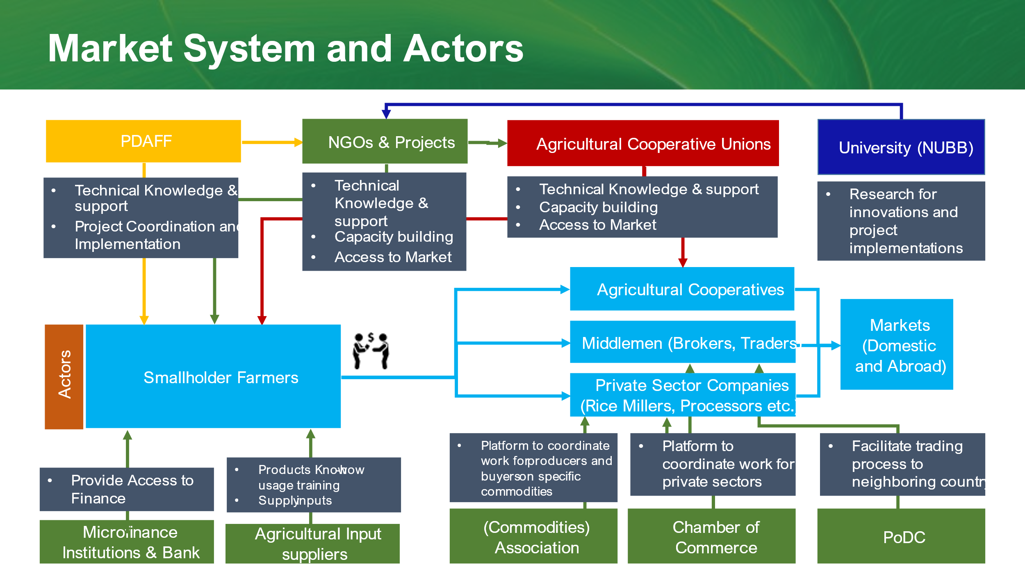

Tips:
- The arrow and actors can be mapped differently to be most relevant to the promoting technology.

